**Question – 1 Write a function to swap values of two in variables of calling function. (TSRS).**

**Ans.**

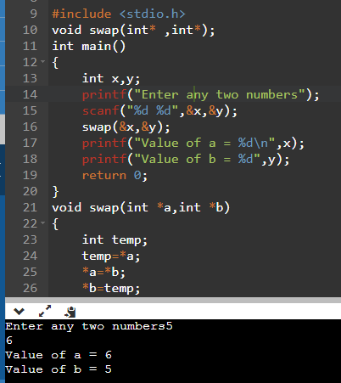

**Question – 2 Write a function to swap strings of two char arrays of calling functions. (TSRS).**

**Ans.**

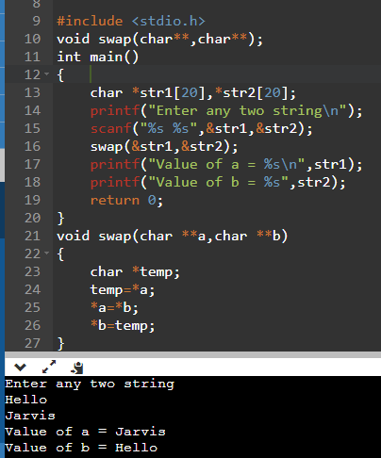

**Question – 3 Write a function to sort an array of int type values. [ void sort(int *ptr,int size); ]**

**Ans.**

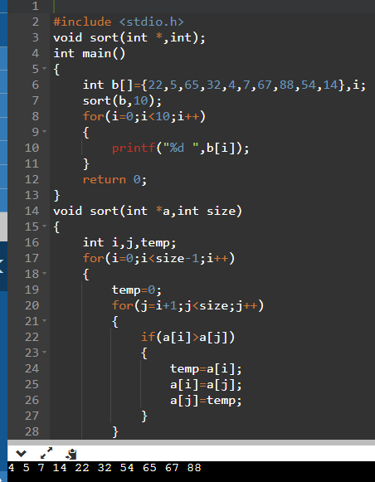

**Question – 4 Write a program in C to demonstrate how to handle the pointers in the program.**

**Ans.**

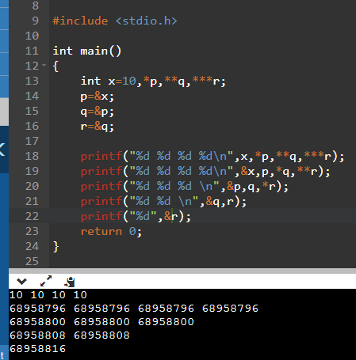

**Question – 5 Write a program to find the maximum number between two numbers using a pointer.**

**Ans.**

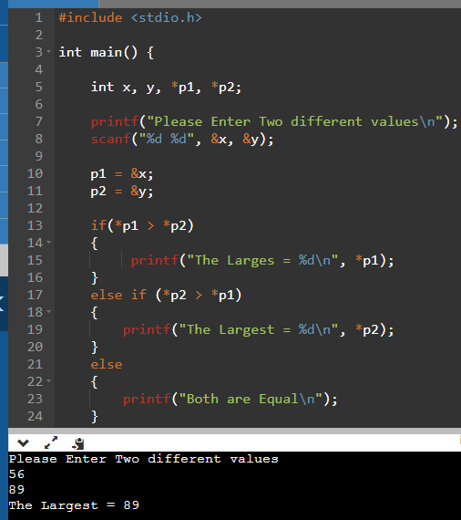

**Question – 6 Write a program to calculate the length of the string using a pointer.**

**Ans.**

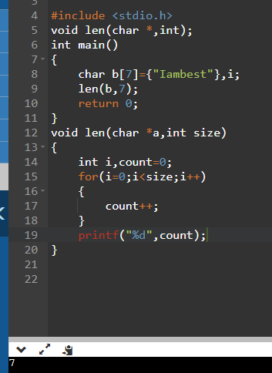

**Question – 7 Write a program to count the number of vowels and consonants in a string using a pointer.**

**Ans.**

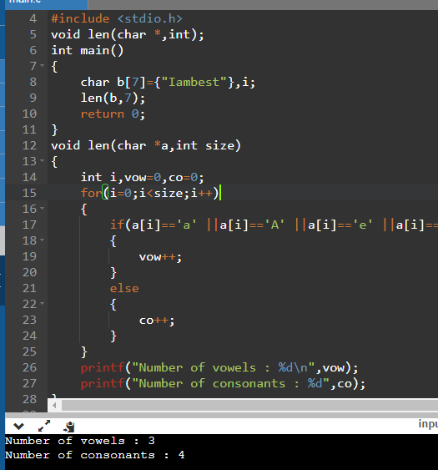

**Question – 8 Write a program to compute the sum of all elements in an array using pointers.**

**Ans.**

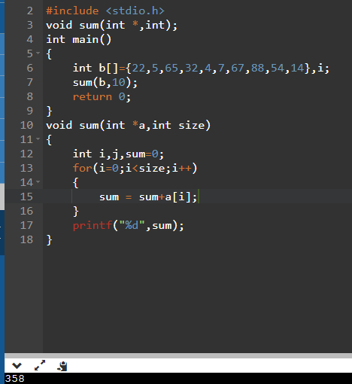

**Question – 9 Write a program to print the elements of an array in reverse order.**

**Ans.**

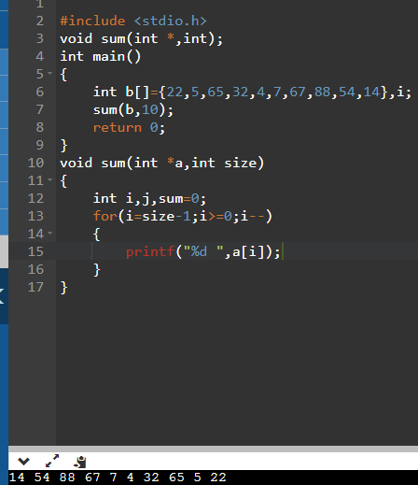

**Question – 10 Write a program to print a string in reverse using a pointer.**

**Ans.**

